# Guidelines for Android Studio Installation and Setup

## Step 1: Download the installation files from the Internet

Start the browser of your PC and the latest version of Android Studio software that is to be installed is searched.

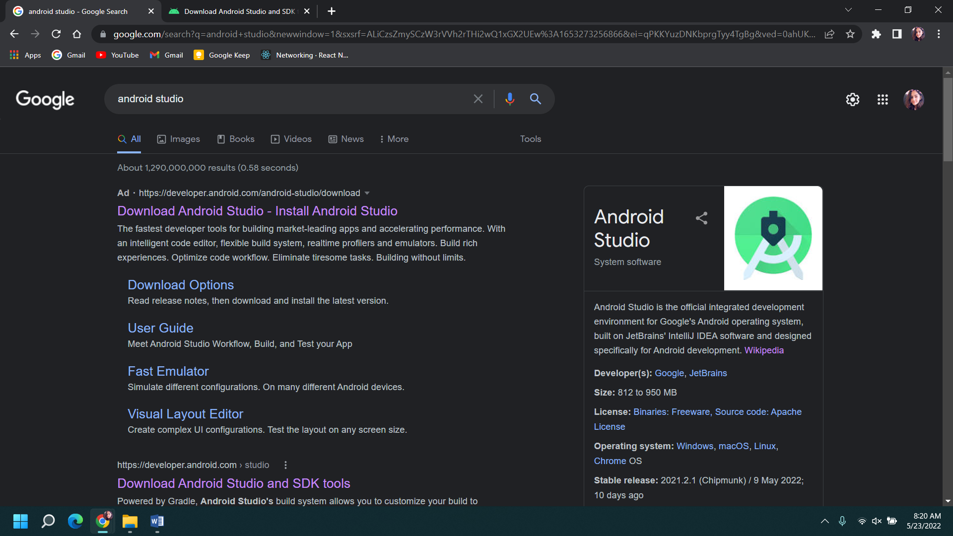

Click on the ‘download’ button and agree to the terms and conditions after the pop-up appears.

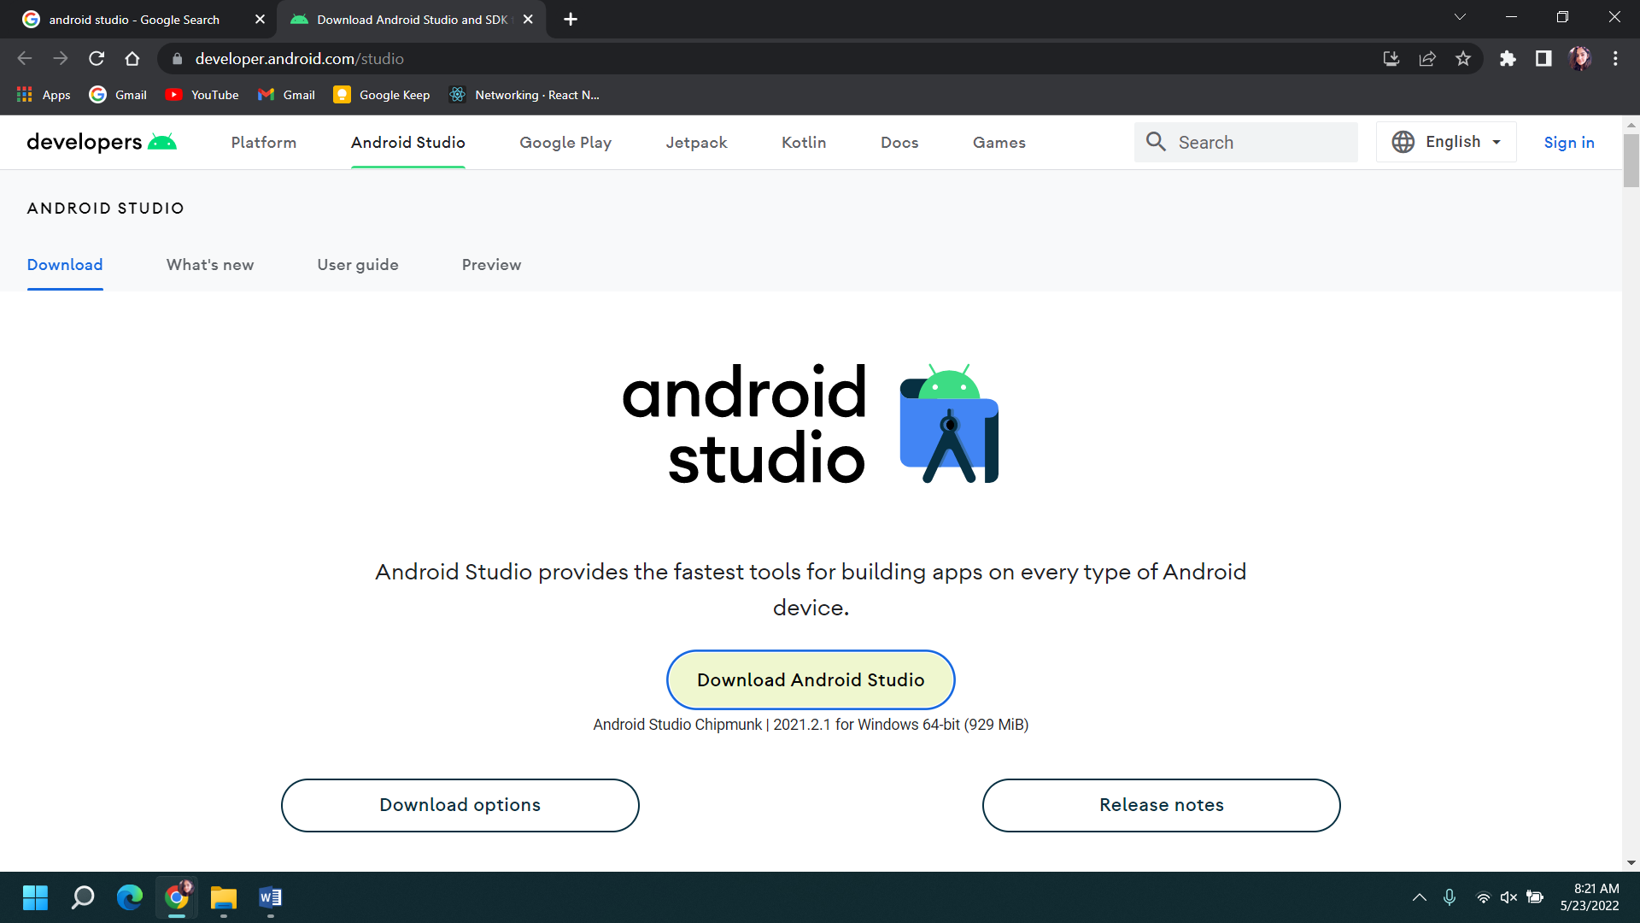

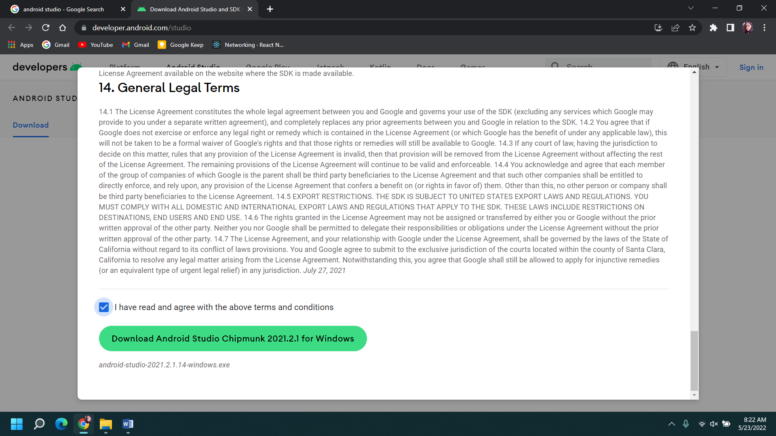

## Step 2: Start the setup wizard

After you continue with the setup, there is an appearance of the set up wizard dialog box, where there is guidance for the installation process and click ‘Next’ to configure further installation process.

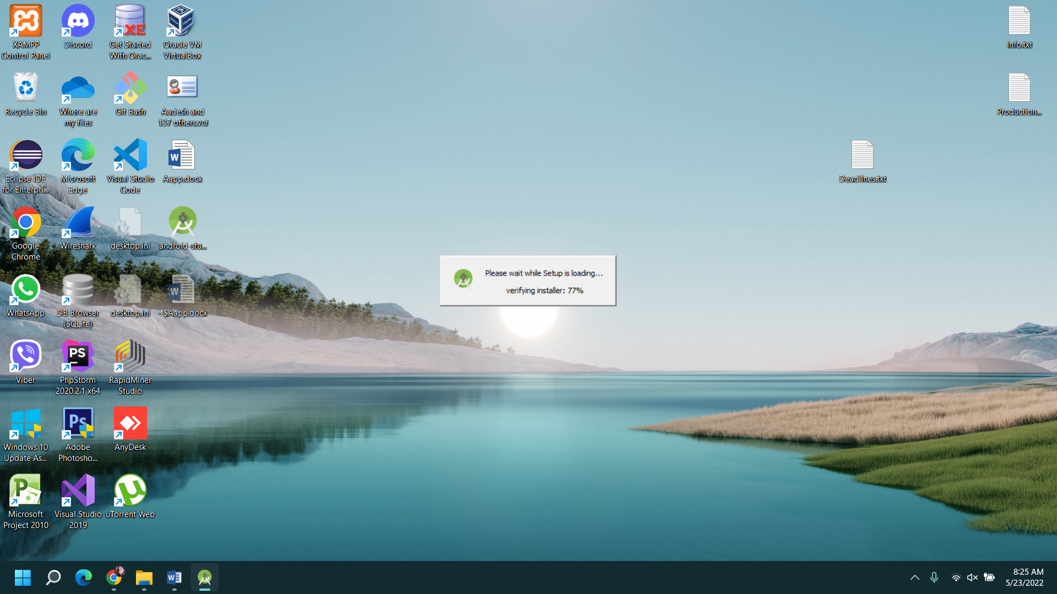

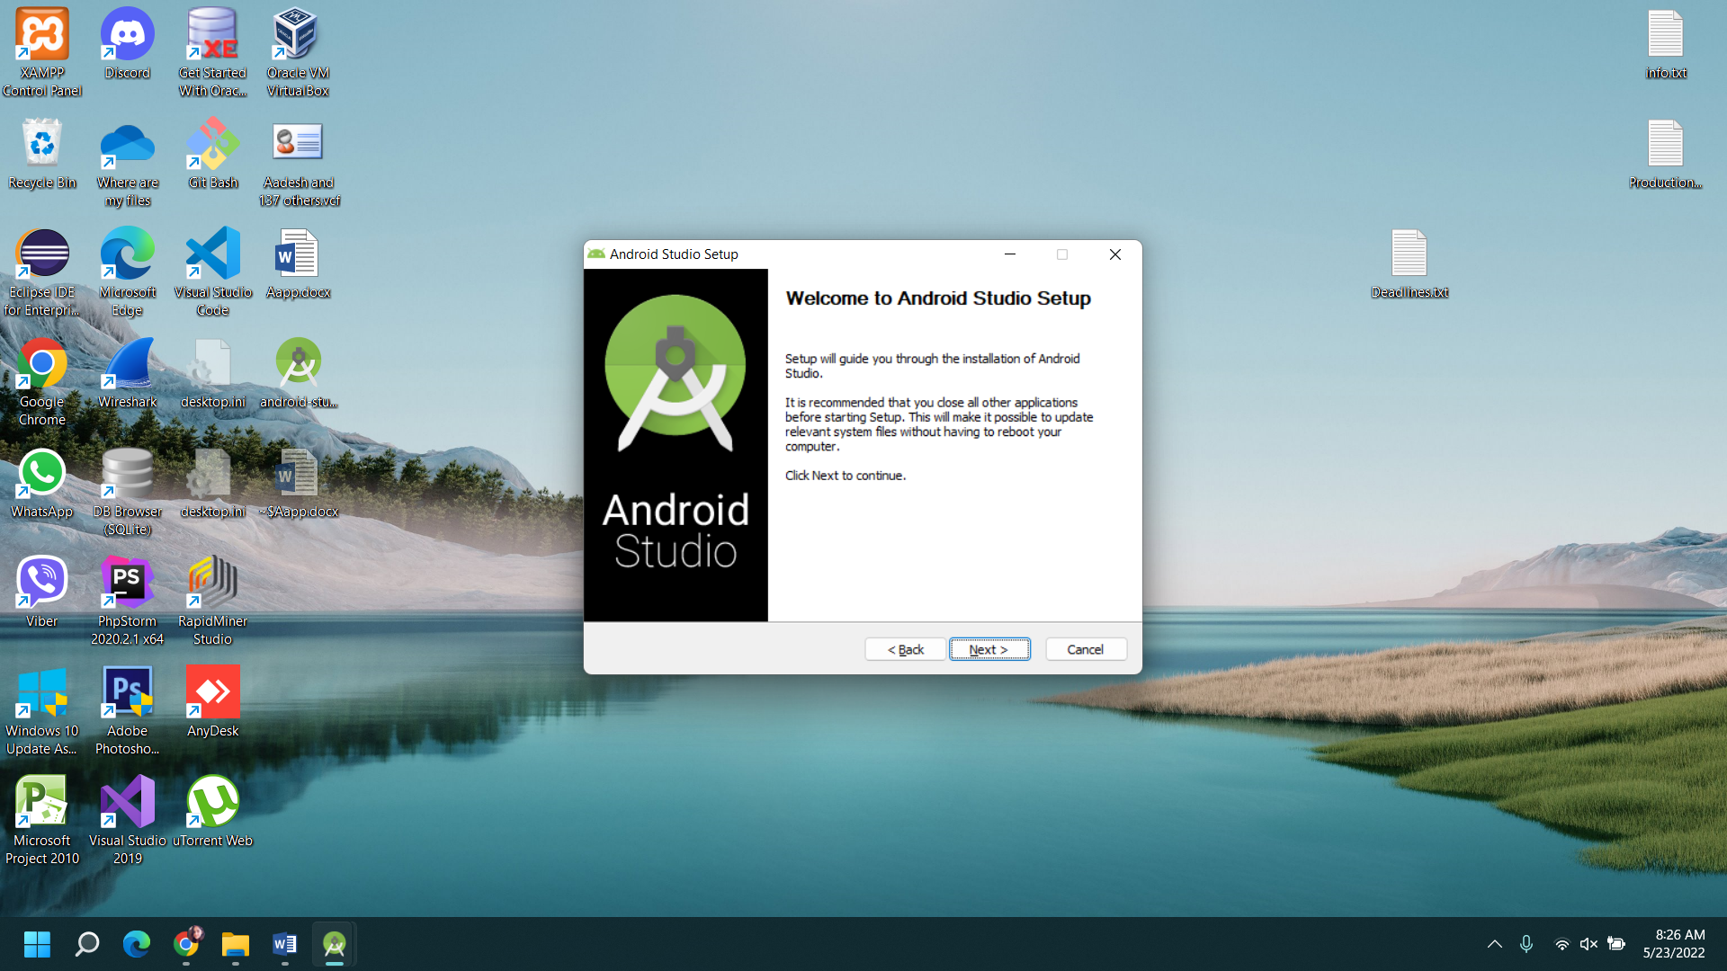

You check for the components that is needed to be installed.

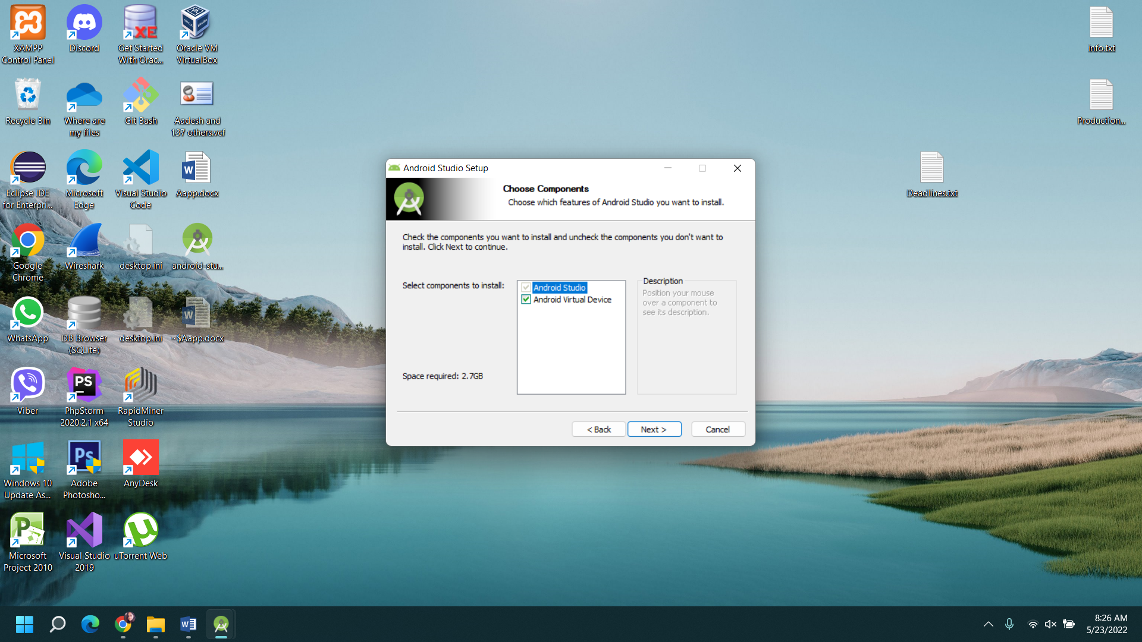

## Step 3: Choose the installation directory

Now, the directory for the downloaded software to be stored in is selected. Click Next after this process.

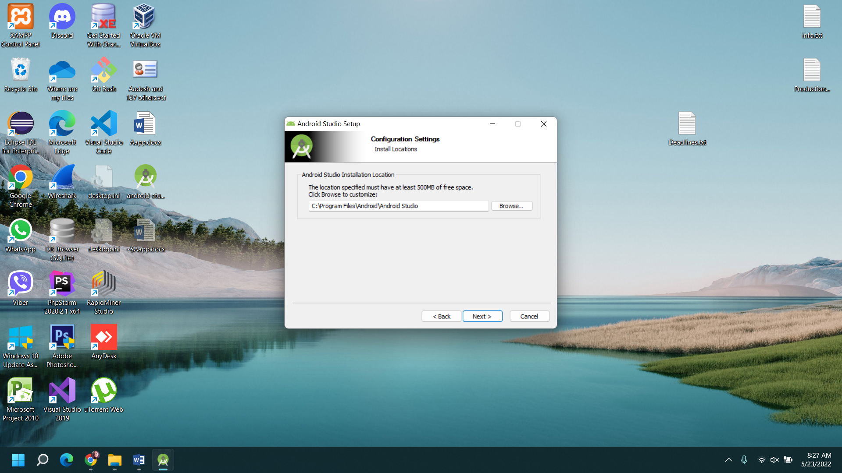

## Step 4: Choose the tasks performed during installation

After clicking on the ‘Next’ button, a menu folder for the shortcuts of the Android Studio to be stored is checked. Click ‘Install’ to begin with the installation process.

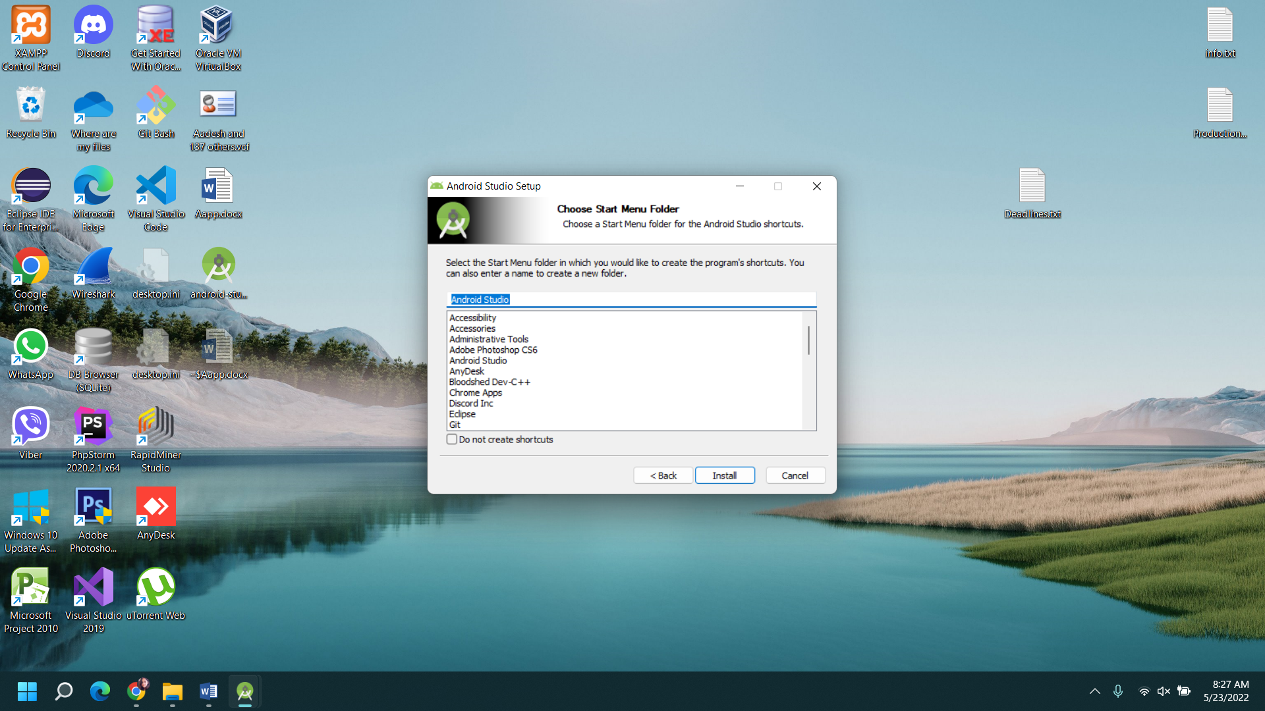

## Step 5: Start installation process

Then click the ‘Install’ button on the setup pop-up screen and the installation process will commence. This may take a few minutes for the software to be installed.

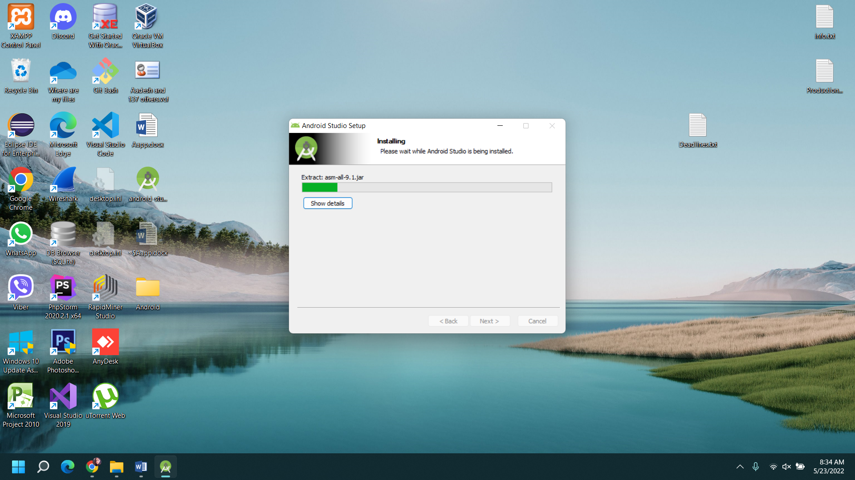

## Step 6: Complete Installation

After the software has been installed, a dialog box is displayed that specifies the user about the completion of installation process. When the ‘Finish’ button is clicked then the process will end. Android Studio is now ready to be used.

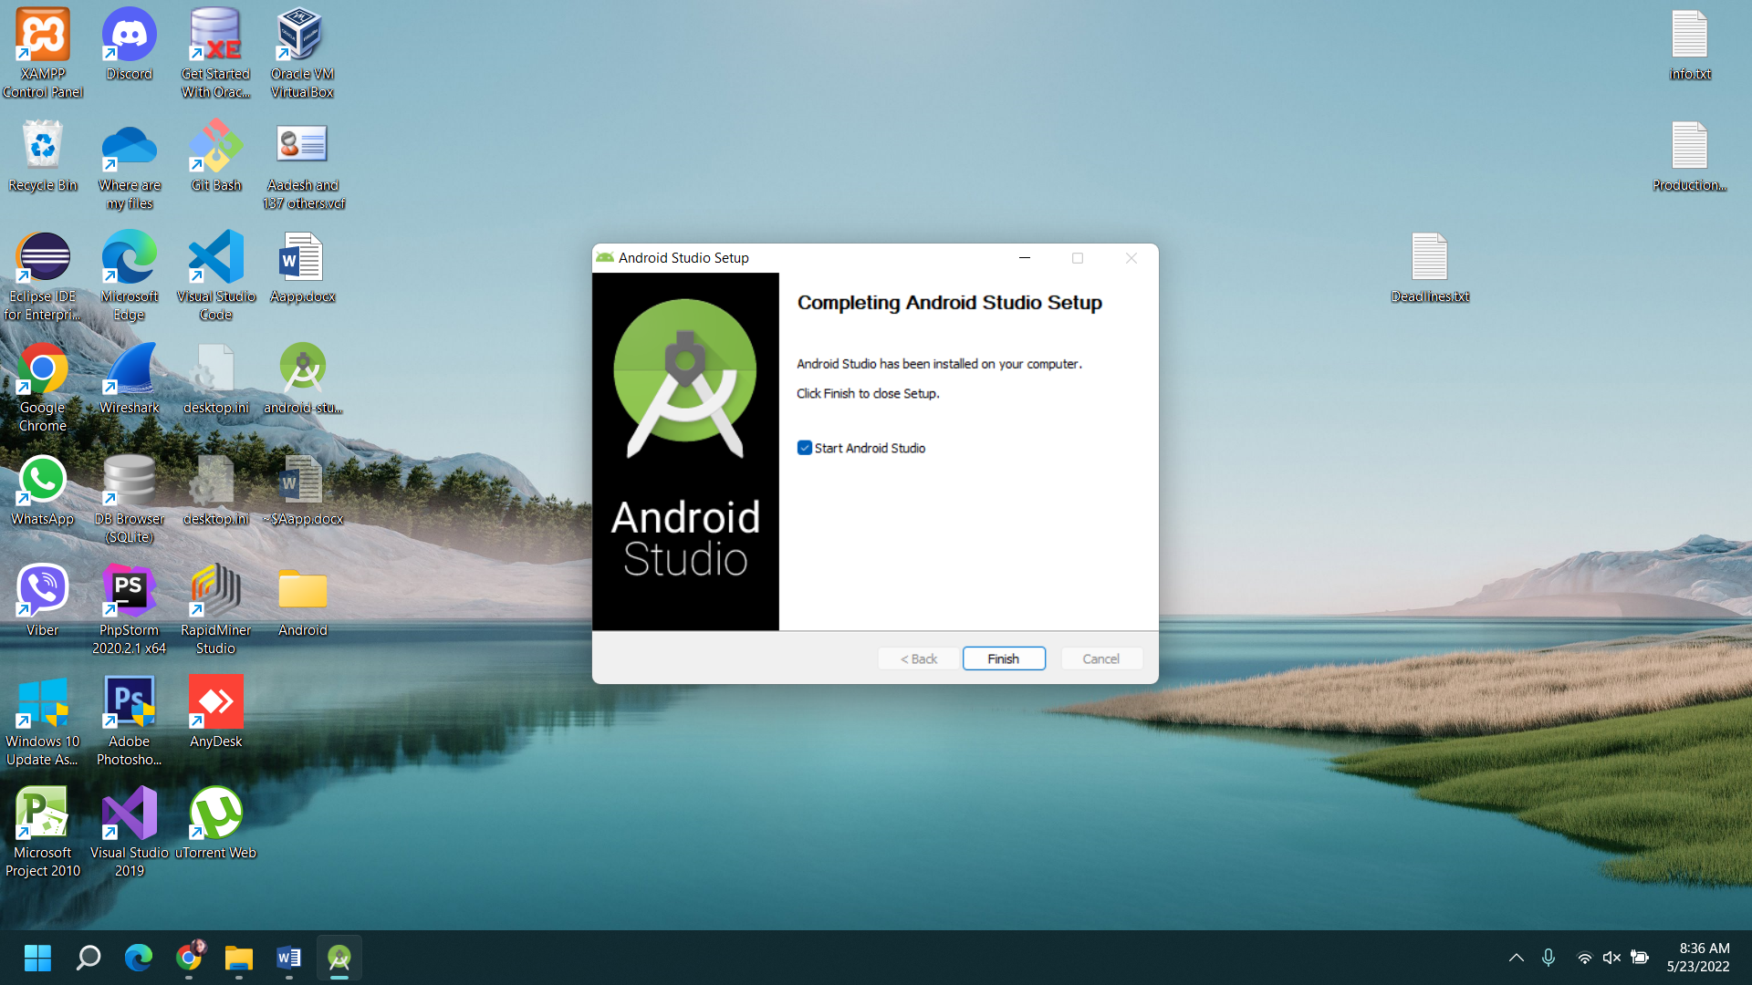

### The Working Area of Android Studio

